## Working Title

“Karma” – Choose your own fate

## Concept Statement

A novel-style, chance-based RPG game like Undertale but with the style of Reigns: Her Majesty. Choose your own fate through your actions while uncovering the story of the world.

## Genre(s)

Role-playing game, novel, strategy, story-based, psychological horror (if you go on a certain path).

## Target Audience

Teens/Young Adults around the age of 15 to mid-20s. Its story based, which gets lasting engagement. Since there will be different endings to the game, depending on how you play, it allows for replayability, which is perfect for that age range since they often have free time.

Desired ESRB rating would be ‘Teen.’ If the psychological horror aspect of the game goes further, it may become a rating for ‘Mature’.

## Unique Selling Points

The game will make you feel like you can control your circumstances, but you must go with fate, and karma will always catch up. Unlike other games, there’s not much action to it. You never have to do any fight sequences (though they will be implied). The amount of endings there can be is also one of its selling points.

One of the unique selling points is the underlying idea that your actions have unforeseen consequences, like the game Undertale. In that game, you can kill monsters around you like in a typical RPG, but doing so will make it to where you can’t get the best ending possible; that made the game unique. ‘Karma’ has the underlying karmic effect that cannot be seen by the player. It will tell the player that they want to overtake ‘Boss’ and it will be assumed that it means pleasing boss by doing all of his jobs, which will actually get you one of the ‘bad’ endings (depending on how you’re looking at it).

## Player Experience

Concept art, done by myself, of what the main character looks like, though it will not be often seen by the player.

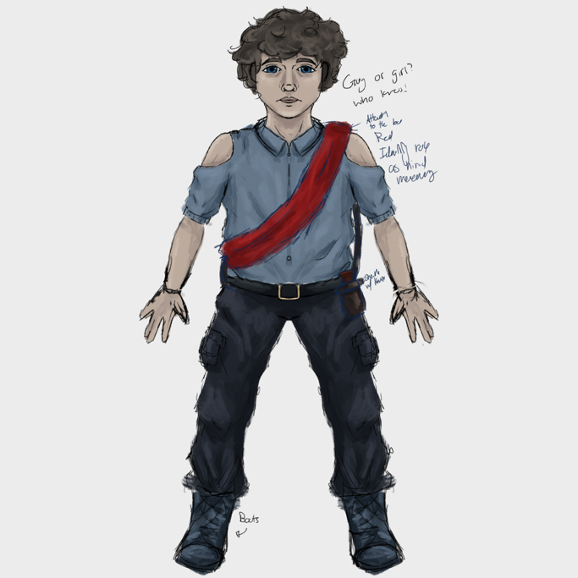

The player is a mercenary who works for a shady underground organization. Before being placed in the game, the MC had worked there for a few years.

The setting is contemporary rustic. It takes place in a modern-day society that doesn’t have some of the technology that we have in the real world. They work in a bustling town full of corruption and kindness.

I want the player to feel a sense of urgency as there is a time limit (though it’s not explicitly stated). They’re in control of their own decisions, and therefore they feel whatever they want to feel for the most part.

## Visual/Audio Style

The video style will be like ‘Reigns: Her Majesty,’ a mobile game in which you act as a queen, and you make choices to that make it to where your kingdom either falls or not. The visual style is very blocky and simplistic. There’s no detail in the art, but the environment is detailed and shows what it needs. Rather than the art consisting of straight lines like the aforementioned game, I wish to make it more pixelated to be reminiscent of earlier RPG games.

Gameplay of ‘Reigns: Her Majesty’ on desktop. It’s optimized for mobile play.

The style supports the player’s experience by making it feel like the world is older and not modern. It helps place the player in a world where technology like ours doesn’t exist. I want it to appear as an unassuming game that contains surface level story but in reality, it has a deeper story.

Concept art of some scenes from the game. Its focus is to show the feel and the intended color scheme of the game in some of the settings.

Audio-wise, the music will be more ‘video game’ like. The best way I can describe it is something like Undertale’s music. It won't be cinematic like some other games, but rather try to install a nostalgic feel.

The music will sometimes be happy or downright terrifying, but it is all based on your game choices. The music will be haunting in the marketplace if you kill everyone. It will be happy and joyous if you help everyone.

## Narrative

You have worked as a mercenary for this organization for many years. You’ve become trusted and have made some allies along the way. Sometimes you must do some…morally ambiguous stuff; you do what you’re assigned. One day, though, ‘Boss’ decides he will choose a successor to the organization soon, and you think you’re perfect for the job. Hopefully, by impressing ‘Boss’ you’ll find yourself as the lead of the organization.

## Platforms(s) and Technology

Made for tablets and not phones, though it will be available (experience will be limited). It utilizes the touch screen, and that is it. It must be played in landscape mode and will have controller integration so people can use their wireless controllers to play.

Since it will be made for tablets, devices such as the iPad that can use a touchpad for a mouse will be able to use it for the game if they want. It will be able to recognize single and double clicks.

There will be autosaves at the beginning of every day.

## Game Rules

The rules that define the world and the gameplay are that there is no modern technology. There are no phones or electronic devices, but there is electricity. Your personal world is made only from the choices that you make. You cannot deviate from the script unless you figure out how. You must make choices that will determine how your game will end.

## Core Loops

Every day in the game, you wake up and receive an assignment from ‘Boss.’ You wake up at 9 am every day. You either need to accept or decline the job. They’re very vague and completely randomized. You don’t know if they’re good or bad. If you accept the job, you go through a scenario of the job happening.

The jobs you get will differ based on your current karma level (a stat hidden from the player). If your karma is high, then the chance of the job being one that raises your karma will be higher. If it’s low, the jobs will be more toward lowering your karma.

You can change your karma outside of assignments by going around the town. There will be a clock that says what time it is and every task will take up time. Time will progress as you play the game. You must go back to your house at 12 am. All tasks are randomized based on the day, the time, and the player’s current karma level.

I hope to see results of people strategizing and replaying to get the ending and result that they wanted.

## Objectives and Progression

The main objective of the game is to take over ‘Boss.’ You can either kill him or not. There are 4 endings to the game: You kill ‘Boss’ and become the boss, you’re chosen as the successor, and you become their right-hand man, you kill ‘Boss’ and set yourself free, or you fail and stay a subordinate forever. There are 2 hidden endings: you are killed off by ‘Boss,’ or you destroy the entire organization.

## Accessibility

There are no flashing lights in the game so there is no seizure risk.

There will be an option to make the text dialogue larger for those with reading disabilities and to make it into a font that is easier to read.

Since the game is mostly text based with no combat controls nor intricate controls there is no need for any accessibility settings for them.

## Monetization

There is no hidden cost to the game. There will be no in-app purchases as they are unnecessary for a game that wishes to only tell a story. I want to make it $2.99 to play and put it on Apple Arcade, allowing subscribers to play it for free.

## Final Inputs

This game isn’t meant to be played for long nor make players want to replay the game years after playing it for the first time. Each week should ideally only take a few hours if you’re reading all of the dialogue texts.

There will be optional dialogue that the player can read that can let them ‘see’ their karma by gauging people’s reactions to them or what they’re saying in reaction to their actions. It may help players to discern what is truly happening in the game by talking to NPCs, which calls for longer play time and more engagement. My goal is to have people playing the game for a few more hours trying to find the hidden lore that will be woven throughout the entire game.

I’ve always been fascinated with games that throw the player for a loop, adding elements that they wouldn’t even think of bringing in a game like the one they’re playing. Other games like this would be something like ‘Doki Doki Literature Club.’ This element is where the genre of psychological horror will come into play.

I hope to include more hidden endings that can only be achieved through replayability such as needing to do a puzzle on a certain day that cannot be done on any other. Once you complete said puzzle, you get an answer that helps figure out a puzzle that happens on another day and may require you to replay the game repeatedly. It’s a rather complicated coding system, so the implementation of it depends on my skill when I come to developing the game.

The plan for the game isn’t very set in stone as my mind constantly changes on what I believe would be a good foot for the game and what I think would perform better for the audience. I have an idea of a game I wish to achieve nut it all relies on my skill as a programmer and my dedication to the game when I make it.

I want to make the most of the hidden lore that appears in the game and make their 2 different stories going on. I want people to think while playing the game or not if they really want a more casual experience. I really want to emphasize the point that the game plays how the *player* wants. If they wish for a surface-level story, then they will get it. If they wish for something deeper that requires thought and decisions, they will get that. The deeper lore can only be accessible if the player wishes to break out of fate and make the game their own, which comes with more hidden endings. While I try to achieve this, the main focus of karma cannot be lost. The idea that fate controls you have to be kept around, and it is a limiter to what I think the story could be but in a good way.

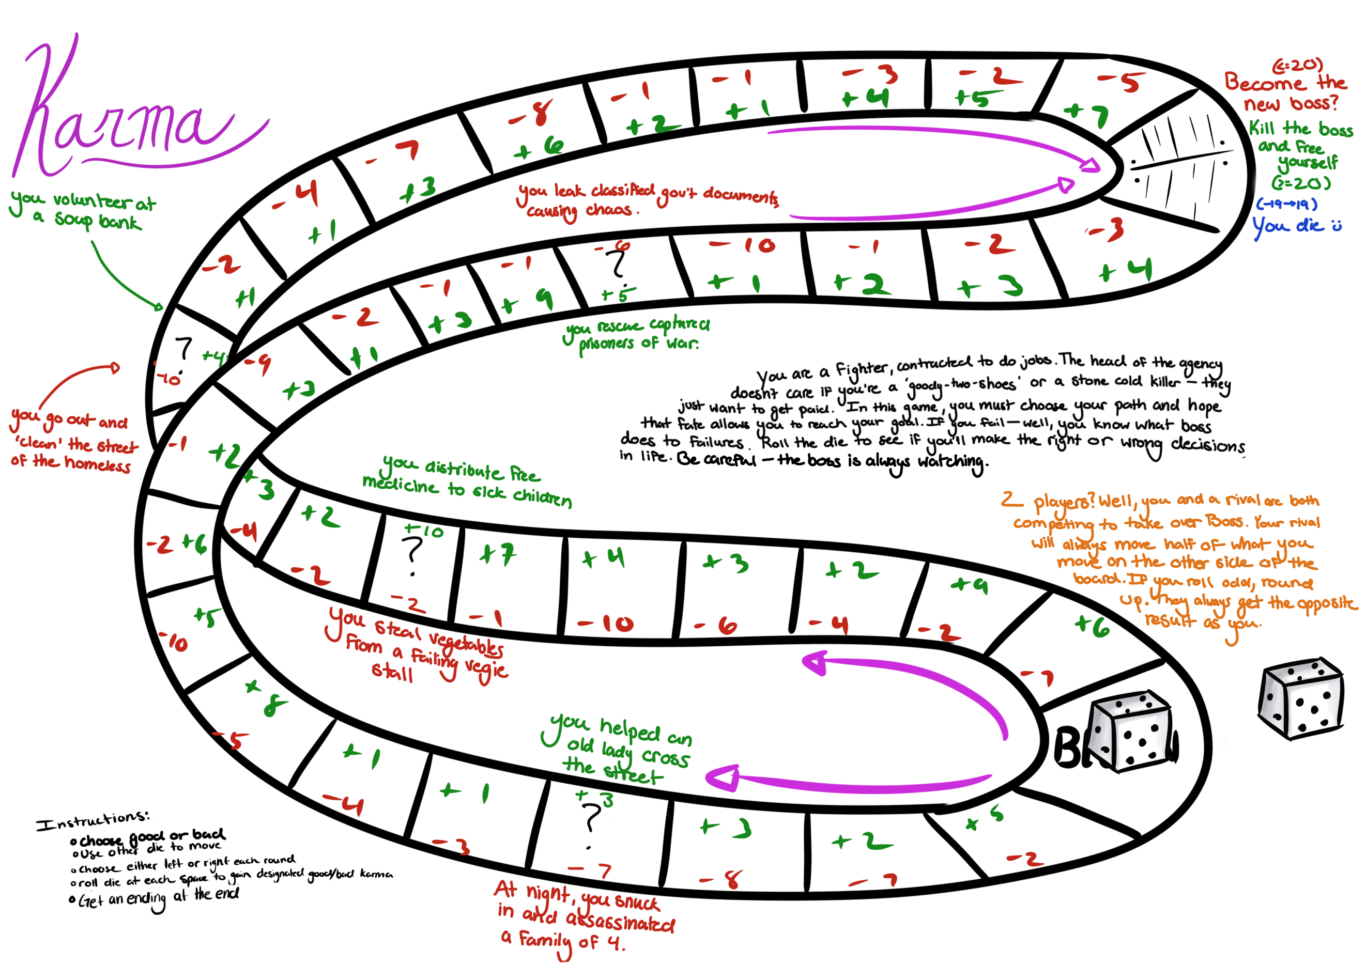

Original game-board design for the game from in class. It incorporated the usage of chance that carried over to the final version. The story remained with the same base ideas. It originally was meant to be played with dice, as per the assignment, but has since evolved into a mobile game idea.

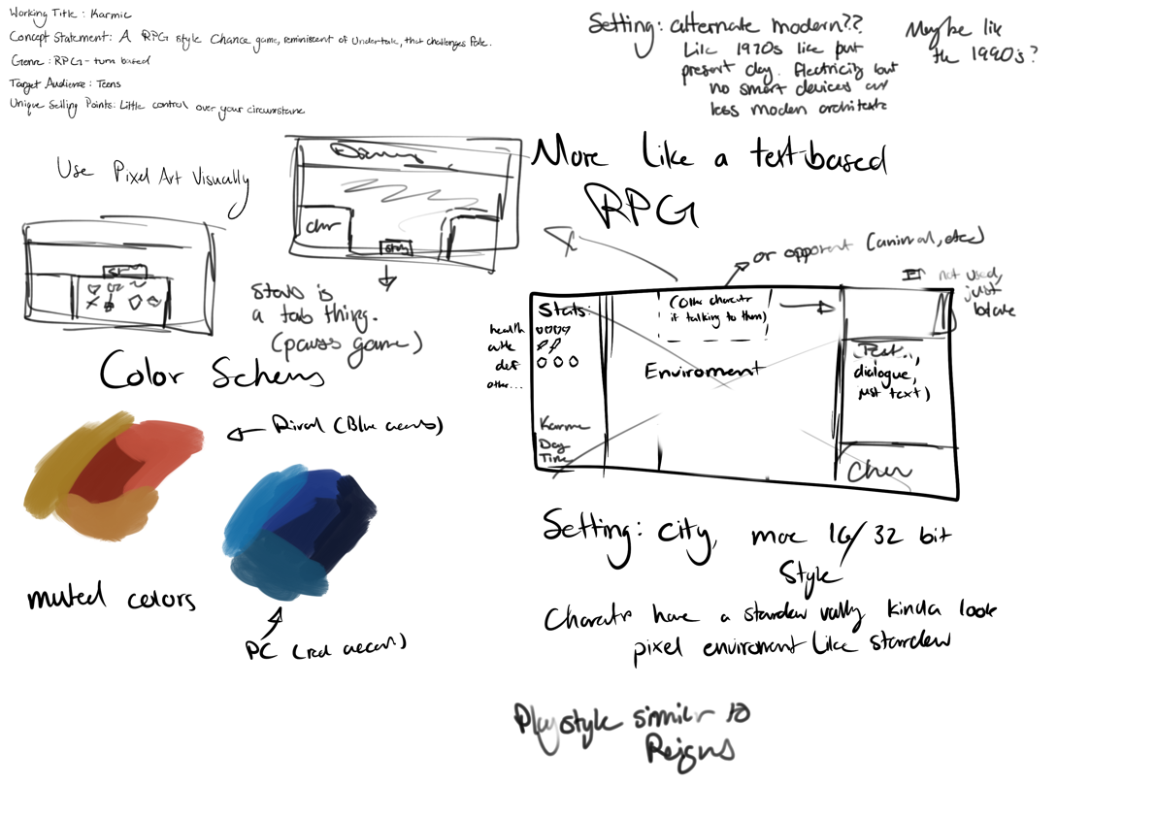

Concept page for the game that discussed the working title, concept statement, genre, target audience, and unique selling points. Ideas of color schemes and layouts are sketched. It emerged to be a landscape only game.

Pictured is a concept page for the game from in class. This one discusses the core loop and feature set, along with the narrative divided into acts. The acts are still present in the game, though more overlapping.

Original plan was to add a rival, which will still be in the game, but will now be an NPC rather than another PC.

# Works Cited

Devolver Digital, 2017. *Reigns: Her Majesty.* [Online]   
Available at: https://www.google.com/url?sa=i&url=https%3A%2F%2Fstore.steampowered.com%2Fapp%2F717640%2FReigns_Her_Majesty%2F&psig=AOvVaw0COZ_XAlOtg3d8D8kIfXMQ&ust=1674823115266000&source=images&cd=vfe&ved=0CBAQjhxqFwoTCNCXzLig5fwCFQAAAAAdAAAAABAE  
[Accessed 26 January 2023].